**Chinook SQL Queries- Postgre**

* 1. **Total sales**

select sum(Total) as Total_sales from invoice;

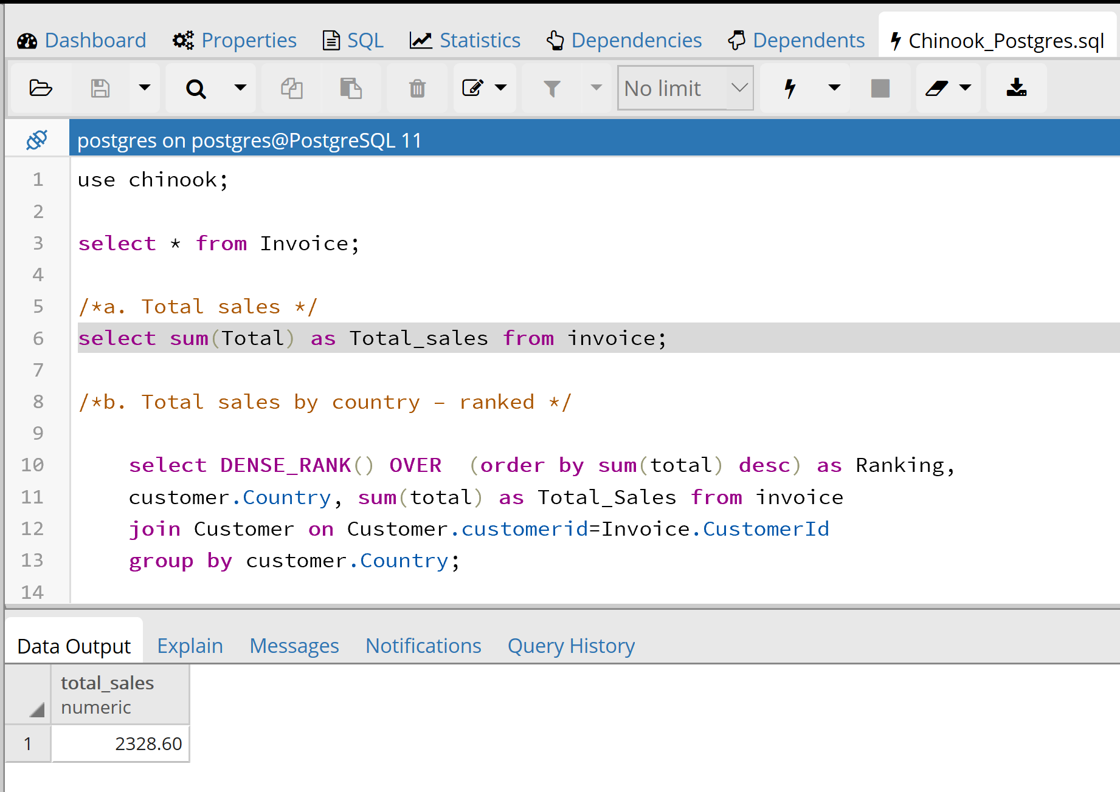

* 1. **Total sales by country – ranked**

select DENSE_RANK() OVER (order by sum(total) desc) as Ranking,

customer.Country, sum(total) as Total_Sales from invoice

join Customer on Customer.customerid=Invoice.CustomerId

group by customer.Country;

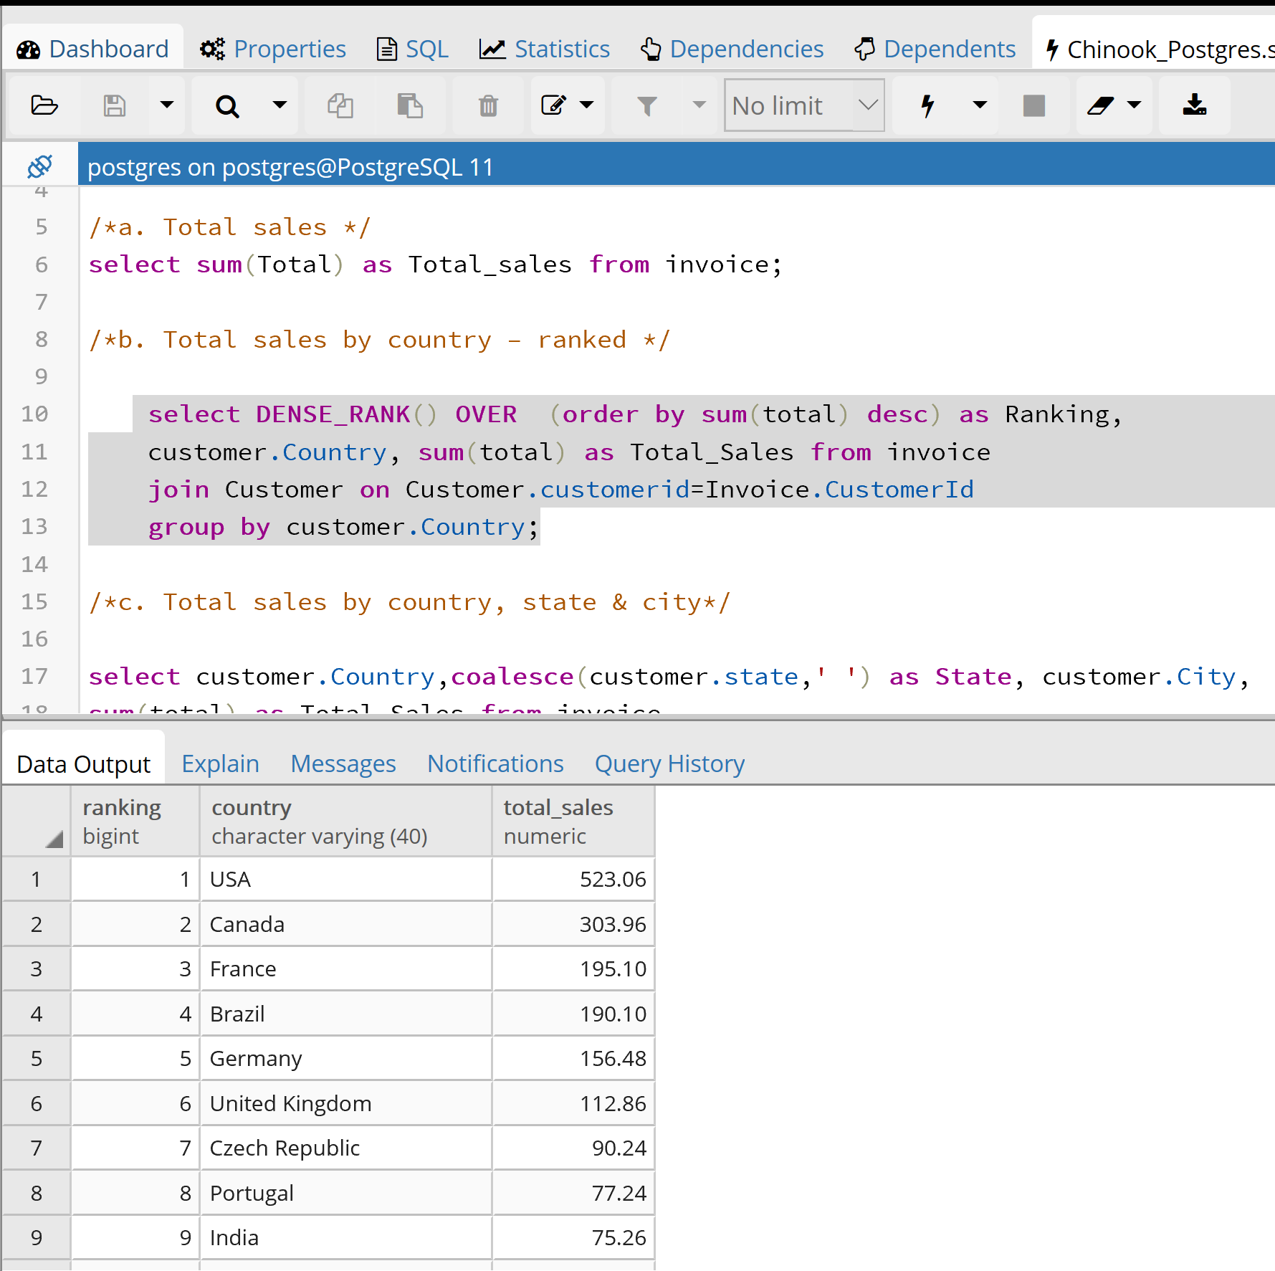

* 1. **Total sales by country, state & city**

select customer.Country,coalesce(customer.state,' ') as State, customer.City,

sum(total) as Total_Sales from invoice

join Customer on Customer.customerid=Invoice.CustomerId

group by customer.Country,Customer.state,customer.City

order by customer.country;

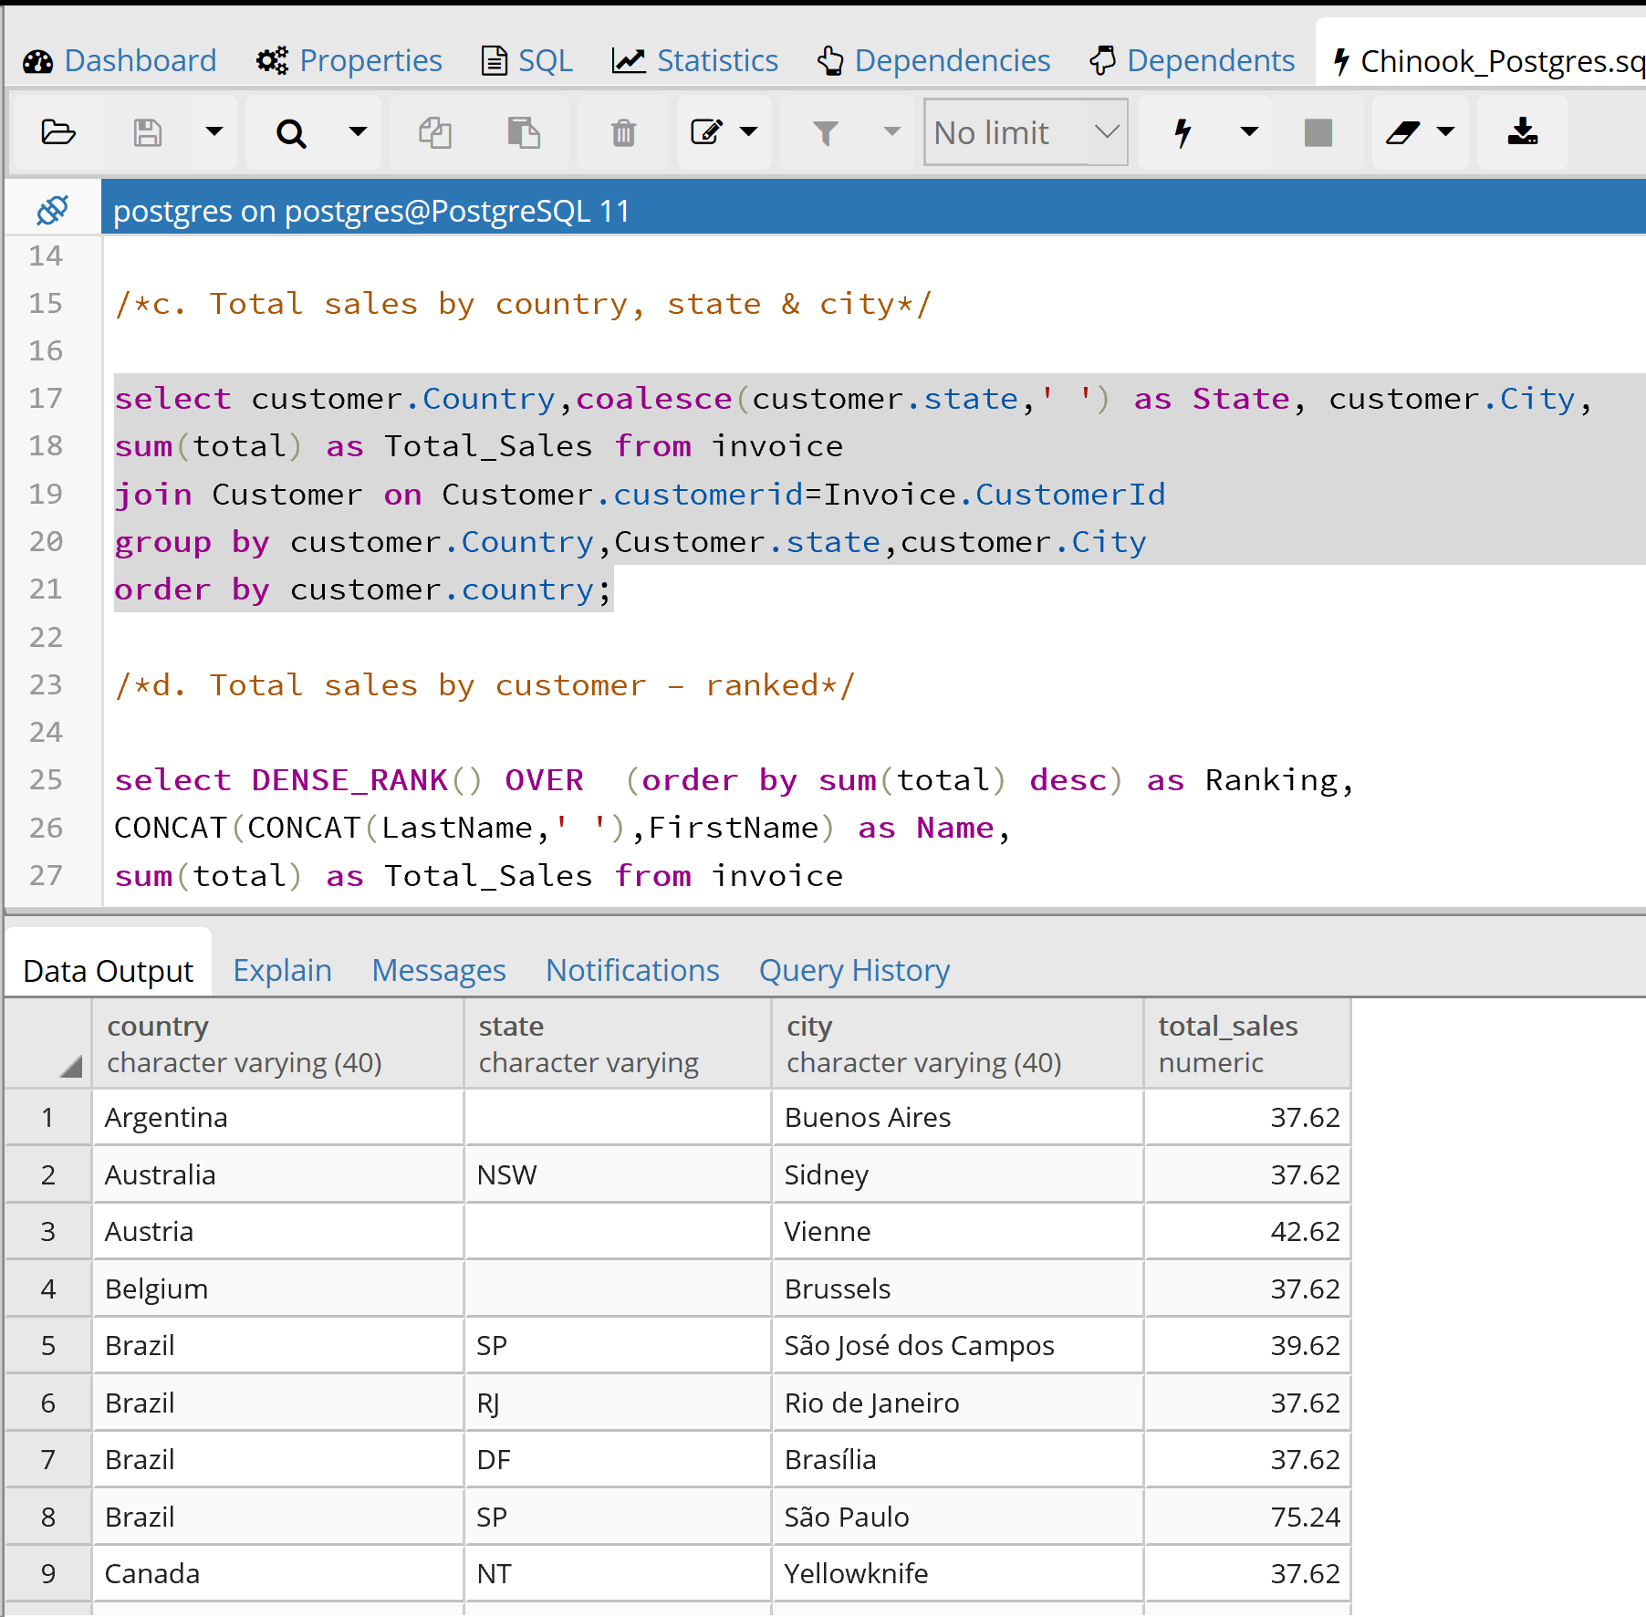

* 1. **Total sales by customer – ranked**

select DENSE_RANK() OVER (order by sum(total) desc) as Ranking,

CONCAT(CONCAT(LastName,' '),FirstName) as Name,

sum(total) as Total_Sales from invoice

join Customer on Customer.customerid=Invoice.CustomerId

group by LastName,FirstName;

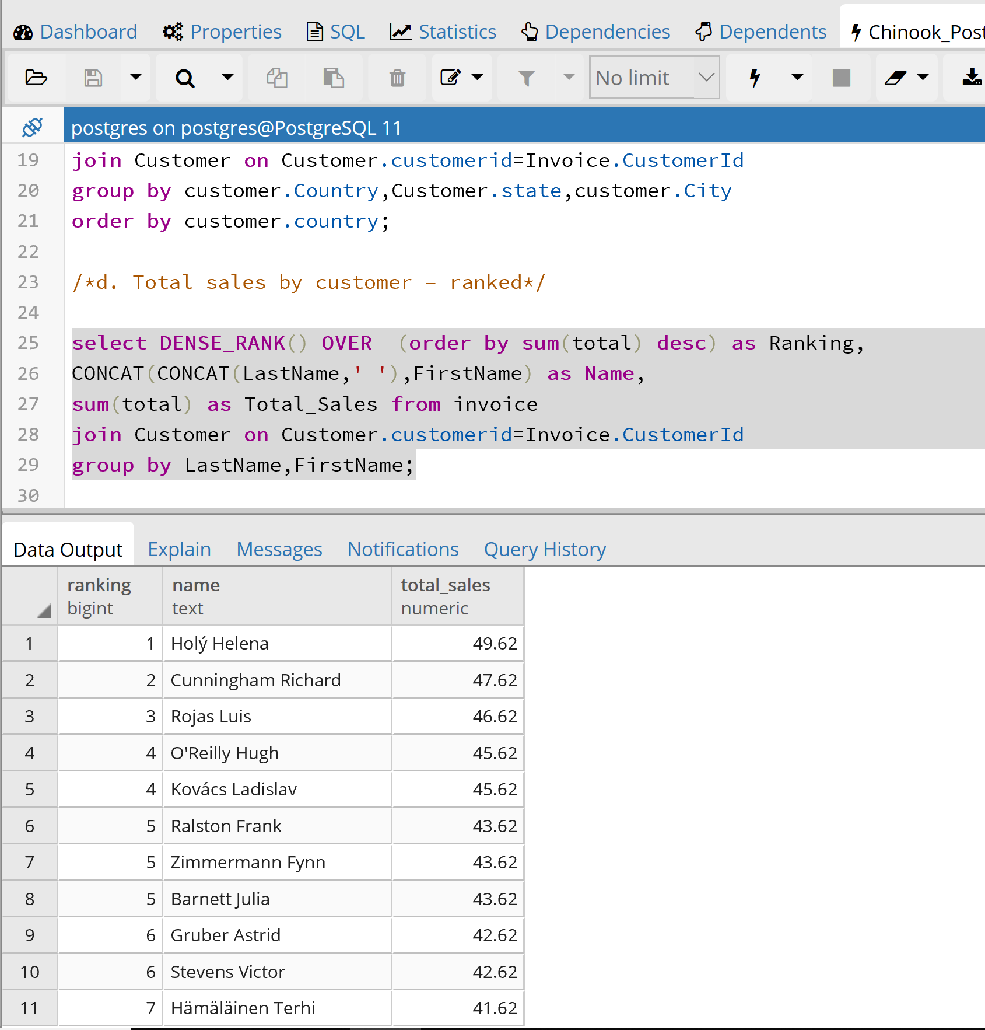

* 1. **Total sales by artist – ranked**

select DENSE_RANK()OVER(order by sum(InvoiceLine.unitprice) desc) as Ranking,artist.name, sum(InvoiceLine.unitprice)as Total_Sales from InvoiceLine

join track on Track.TrackId=InvoiceLine.TrackId

join album on album.AlbumId=track.AlbumId

join artist on Artist.ArtistId=Album.artistid

group by artist.name;

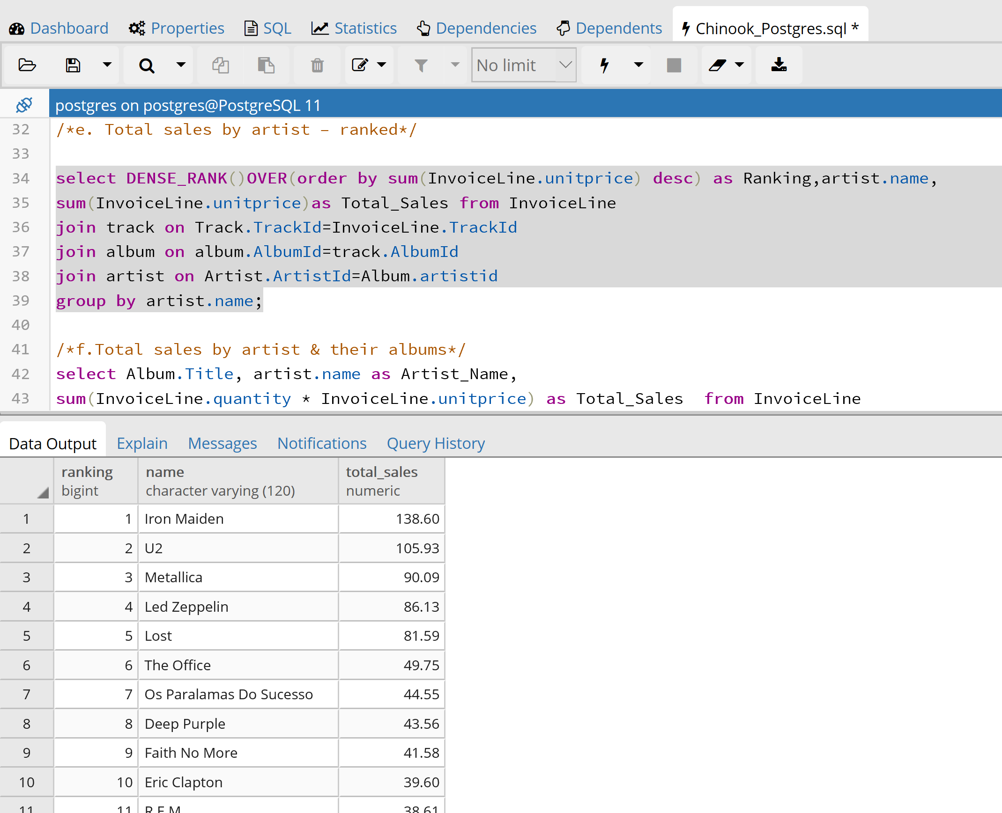

* 1. **Total sales by artist & their albums**

select Album.Title, artist.name as Artist_Name,

sum(InvoiceLine.quantity * InvoiceLine.unitprice) as Total_Sales from InvoiceLine

join track on Track.TrackId=InvoiceLine.TrackId

join album on album.AlbumId=track.AlbumId

join artist on album.artistid=artist.artistid

group by Album.Title, artist.name

order by Total_sales desc;

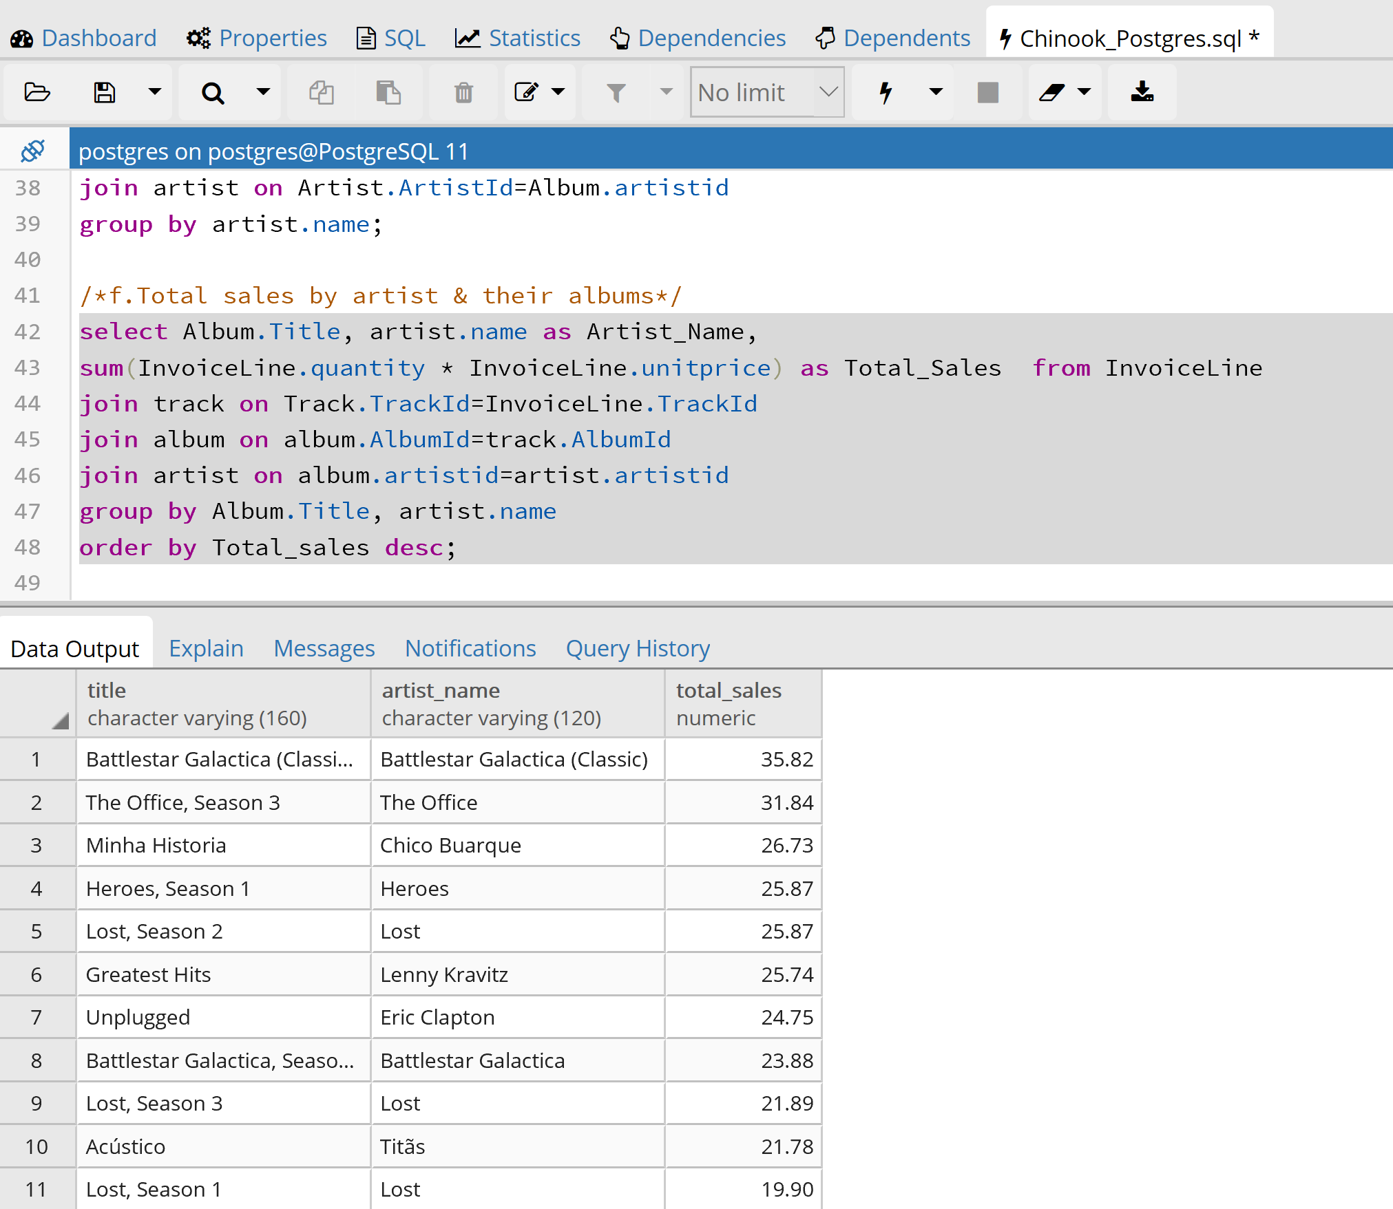

* 1. **Total sales by sales person (employee)**

select CONCAT(CONCAT(e.LastName,' '),e.FirstName) as Name,

sum(total) as Total_Sales from Invoice

join Customer on Customer.customerid=Invoice.CustomerId

join Employee e on e.EmployeeId=customer.SupportRepId

group by e.Lastname,e.FirstName

order by Total_Sales desc;

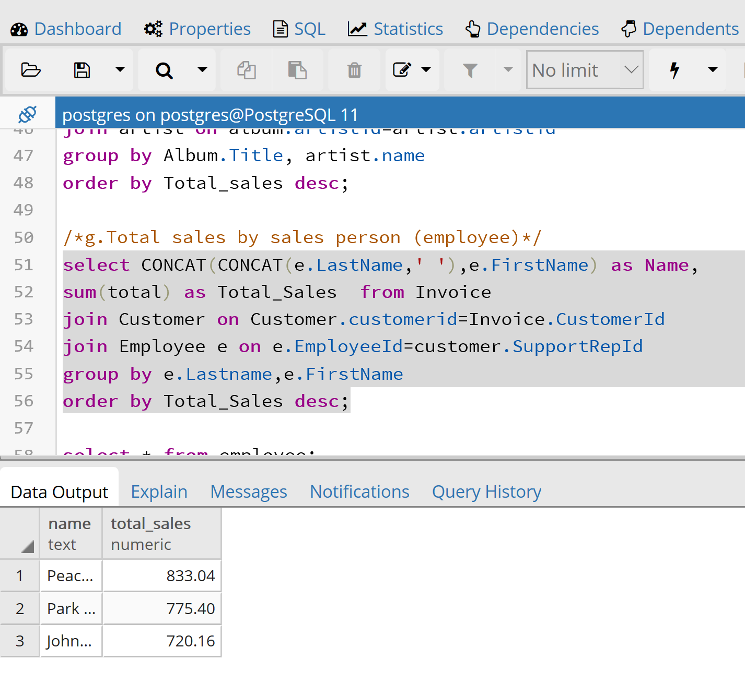

* 1. **Total tracks bought and total cost by media type**

select MediaType.name,sum(il.quantity * il.unitprice) as Total_Sales,

count(il.Quantity) as Quantity from InvoiceLine il

join track on Track.TrackId=il.TrackId

join MediaType on MediaType.MediaTypeId=track.MediaTypeId

group by MediaType.name,il.Quantity

order by Total_Sales desc;

